# Name Date

The Past Tense – Simple Past

***There are three aspects of the past tense:***

1. **Simple past A picture containing shape

   Description automatically generated** = action

The **simple past tense** is used to describe:

* 1. an action that happened in the past
  2. a truth about a time in the past
* Add “**ed”** or “**ied”** to *regular* verb endings in simple past tense when used to describe any subject (**I, you, we, they, he, she, it**).

Subject [verb + “ed” or “ied”]

# The verb “**to be”** has an irregular conjugation:

I / he / she / it [was] you / we / they [were]

Example: He walked to school yesterday.

Example: She was happy.

# Directions: Write the correct form of the verb in the spaces below.

1. When I was in school, I (to do) my homework everyday.

# She liked (to like) chocolate milk when she was a girl.

1. It always (to rain) when we lived in Seattle.

# Joey and Mike (to be) friends a long time ago.

1. I (to try) to make a snowman last winter.

# Our favorite game when we were little (to be) chess.

1. It (to be) so sunny yesterday.

# Jeremy (to want) to go to the beach this summer.

1. Shelby (to save) $100.

# It (to snow) last December.

Directions: Put the following sentences in simple past tense.

# I talk to Anne on the phone.

1. Nikko laughs at the joke.

# Directions: Now make your own sentences using the simple past tense.

***1)***

***2)***

**NAME: DATE:**

**GRAMMAR WORKSHEET**

PAST SIMPLE: Irregular 

|  |  |  |  |  |  |  |  |
| --- | --- | --- | --- | --- | --- | --- | --- |
| I | **ate** | dinner. |  | I | **didn’t** | eat | dinner. |
| You | You |
| He | He |
| She | She |
| It | It |
| We | We |
| They | They |

**Yes, No,**

* ***Fill in the blanks below to complete the sentences. Study the boxes above.***

|  |  |  |  |  |  |  |  |  |
| --- | --- | --- | --- | --- | --- | --- | --- | --- |
| **Did** | I | eat | dinner? |  | I | **did.** | I | **didn’t.** |
| you | you | you |
| he | he | he |
| she | she | she |
| it | it | it |
| we | we | we |
| they | they | they |

# Icon Description automatically generatedI *(eat)* dinner at six o’clock yesterday.

1. A: Helen *(drive)* to work? B: Yes, she .

# My neighbor *(buy)* a new car last week.

1. They *(go)* to Italy on their last summer holiday.

# A: they *(swim)* at the beach? B: No, they .

1. My family and I *(see)* a comedy movie last night.
2. First, we *(do)* exercise, and then we *(drink)* some water.

# Suddenly, the animal jumped and *(bite)* my hand.

1. What time *(do)* you *(get up)* this morning?

# The Wright brothers *(fly)* the first airplane in 1903.

1. I think I *(hear)* a strange sound outside the door one minute ago.
2. When I was ten years old, I *(break)* my arm. It really *(hurt)* .

# The police *(catch)* all three of the bank robbers last week.

1. How many times *(do)* you *(read)* that book?
2. Unfortunately, I *(forget)* to *(bring)* my money

_

_

_

_

a

Name: Date:

Read the clues and then complete the puzzle.

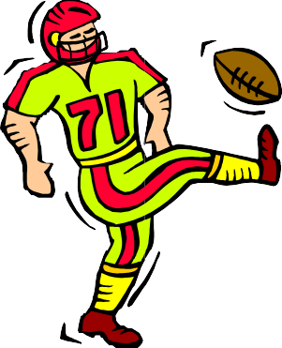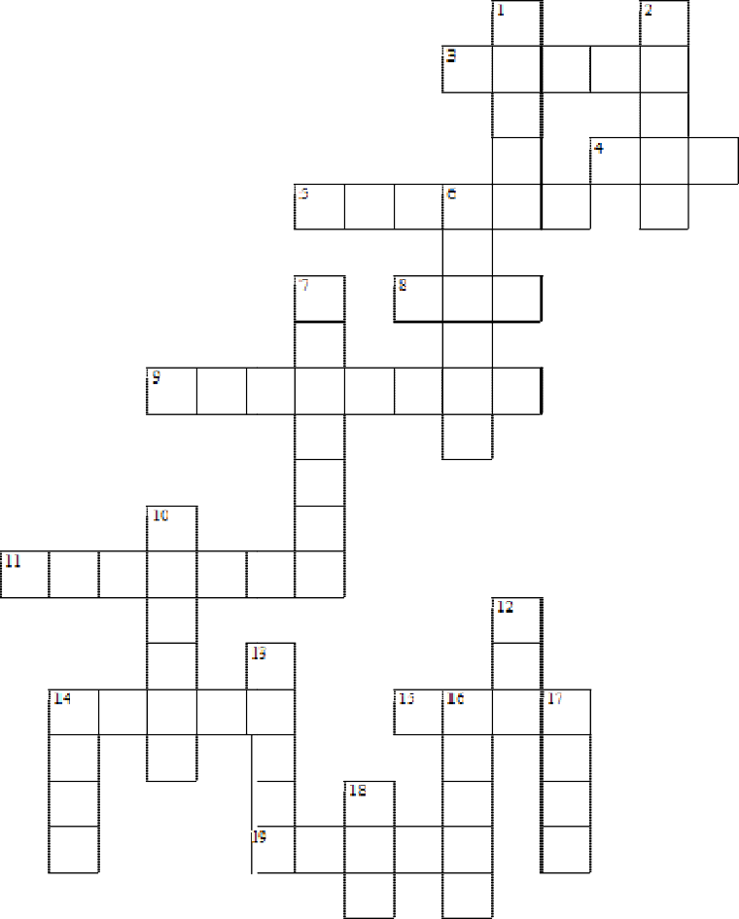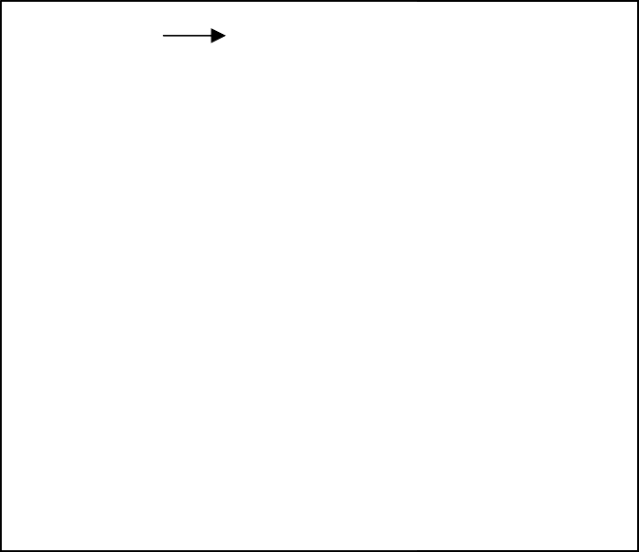

***Across:***

3

4

5

8

9

11

14

15

sky 19

the past tense of break the past tense of have _ the past tense of jump the past tense of run yesterday I _ to music the past tense of dream _ the past tense of sleep _

this morning many birds _ in the

the past tense of drive

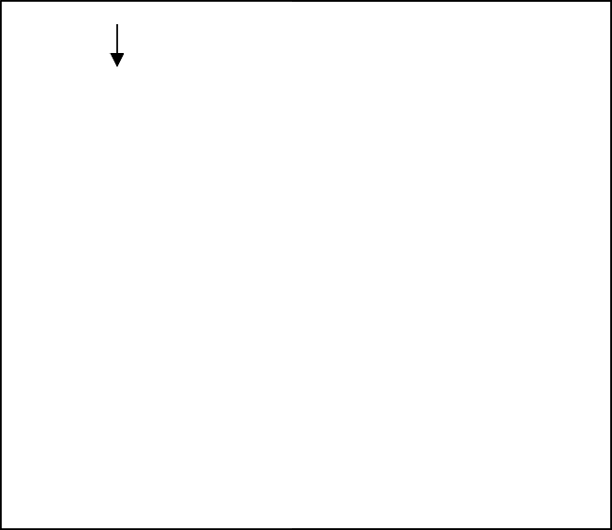

***Down:***

1. the past tense of write
2. the past tense of begin
3. last year he _ football
4. the past tense of w tch

10 the past tense of rain

1. the past tense of eat
2. the past tense of stand _
3. the past tense of swim
4. He used to love his girlfriend
5. the past tense of go
6. the team a lot of trophies

**Past Simple**

## Write the Past Simple of each verb in the correct column.

open marry like try bake stop mix plan repeat worry decide travel

|  |  |  |  |
| --- | --- | --- | --- |
| **-ed** | **-d** | **-ied** | **double consonant + -ed** |
| *opened* |  |  |  |
|  |  |  |  |
|  |  |  |  |

1. **Complete the sentences with the Past Simple of the verbs in brackets.**
   1. My sister .......*t*.*r*..*i*.*e*..*d* (try) to bake a cake

last Saturday.

* 1. We (not order) steak and chips

at the restaurant yesterday.

* 1. I (phone) my cousin in Canada

three days ago.

* 1. The children (play) on the

computer yesterday.

## Write the questions. Then answer them.

1. you / watch TV / last night

.*D*...*i*.*d*....*y*..*o*..*u*...*w*....*a*..*t*.*c*..*h*....*T*..*V*....*l*.*a*..*s*..*t*...*n*..*i*.*g*..*h*..*t*..*?*...................

.*Y*..*e*..*s*..*,*..*I*..*d*..*i*..*d*..*.* .*/*...*N*...*o*..*,*..*I*...*d*..*i*.*d*..*n*..*’*.*t*.*.*.................

1. your friends / play football / yesterday

.......................................................................

.........................................................

1. your mum / bake / a cake / last weekend

.......................................................................

.........................................................

1. you / phone / a friend / an hour ago

.......................................................................

.........................................................

## Write the Past Simple form of the verbs.

|  |  |  |  |  |  |  |  |
| --- | --- | --- | --- | --- | --- | --- | --- |
| 1 take | .......*t*..*o*..*o*..*k*........ | 4 | give | ..................... | 7 | go | ..................... |
| 2 drink | ..................... | 5 | think | ..................... | 8 | wake | ..................... |
| 3 ride | ..................... | 6 | have | ..................... | 9 | buy | ..................... |

1. **Write questions with the words below. Then answer the questions according to the pictures.**

## Use the Past Simple.

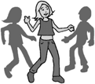

**2**

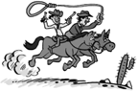

**3**

*1880s*

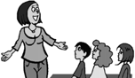

**4**

Good morning!

**1**

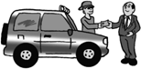

buy a jeep wear jeans ride horses speak English

1. Rob / buy a small car

.*D*...*i*.*d*...*R*....*o*..*b*...*b*..*u*..*y*....*a*...*s*..*m*...*a*..*l*.*l*..*c*..*a*..*r*..*?*..............................

.*N*...*o*..*,* ..*h*..*e*...*d*..*i*.*d*..*n*..*’*.*t*..*.* .*H*...*e*....*b*..*o*..*u*..*g*..*h*..*t*...*a*...*j*.*e*...*e*..*p*..*.* ...................

1. Jenny / wear a skirt / to the party

..........................................................................

..........................................................................

1. cowboys / drive cars / in the 1880s

..........................................................................

..........................................................................

1. the teacher / speak Greek / in the lesson

..........................................................................

..........................................................................

**Simple Past (interrogative)**

## Write these questions in the past.

1. Does she buy the newspaper in the shop over there? ...............................................

2. Do they do their homework in the evening? ...............................................................

3. Do they have a good holiday? ....................................................................................

4. Do they find any animal in the forest? ........................................................................

5. Is it dark when she gets up in the morning? ...............................................................

## Write questions for these answers.

*1. Where did you go yesterday?*

I went to the park

2. ...............................................?

My friend arrived at five o´clock

3. ................................................?

He said “hello!”

4. .................................................?

The film started at seven.

5. .................................................?

We went on a excursion.

6. ..................................................?

She visited her aunt.

7. ................................................. ?

My grandparents lived in Italy.

## 3. Write questions in the past with these words.

1. when / study English / you ?
2. what / do / yesterday / she ?
3. like / the film / he ?
4. live / in Paris / your parents ?
5. walk / down / the road / they ?

## Answers

**Simple Past (negative and affirmative)**

**1. Write these sentences in the past.**

1. He goes to the swimming pool because he likes swimming.

…………………………………………………………………………………………

1. They have dinner at nine o´clock.

…………………………………………………………………………………………

1. Adam runs 500 m

…………………………………………………………………………………………

1. Helen eats too many sweets.

…………………………………………………………………………………………

1. I buy the newspaper in the shop.

…………………………………………………………………………………………

1. We get up at eight o´clock and go to school.

…………………………………………………………………………………………

1. **Write the sentences in exercise 1 in the negative form.**

1. …………………………………………………………………………………………

2. …………………………………………………………………………………………

3. …………………………………………………………………………………………

4. …………………………………………………………………………………………

5. …………………………………………………………………………………………

6. …………………………………………………………………………………………

1. **Write about what Jim did and didn´t do yesterday**, **as in the examples.**
2. Go to the bank (yes) *1. He went to the bank*
3. Buy some shoes (no) *2. He didn´t buy any shoes*.

3. Write to Sally (yes) ……………………………………..

4. Buy a shirt (yes) ……………………………………..

5. Have lunch with Adam (no) ……………………………………..

6. Write to Peter (yes) ……………………………………..

7. Go to the hospital (no) ……………………………………..

8. Have dinner with Susie (yes) ……………………………………..

9. Play football (no) ……………………………………..

10.Make dinner (yes) ……………………………………..

1. **Write the past form of these verbs.**

|  |  |  |  |
| --- | --- | --- | --- |
| 1. to get | ……… | 6. to play | ……… |
| 2. to buy | ……… | 7. to come | ……… |
| 3. to study | ……… | 8. to go | ……… |
| 4. to watch | ……… | 9. to pay | ……… |
| 5. to begin | ……… | 10. to walk | ……… |